Project 3

Airline Flight Delay Analysis

1. How does the overall flight volume vary by month? By day of week?

Ans. The chart below encapsulates the flight volume variation by month.

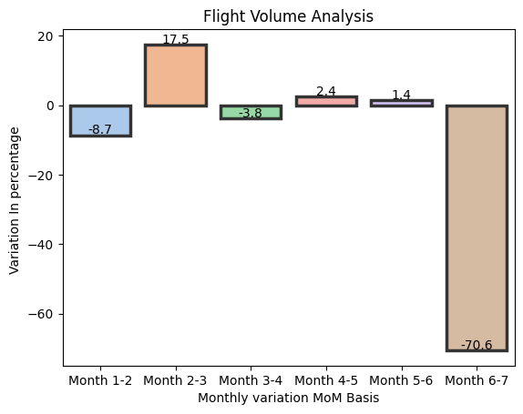

Daily basis

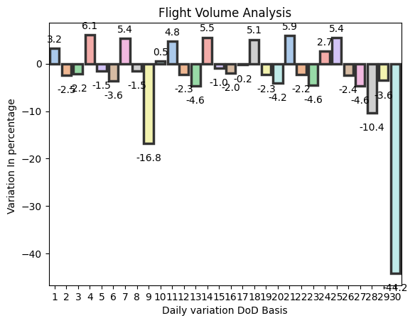

2) i.) What percentage of flights experienced a departure delay in 2015?

Ans. 61.6% of the flights that took off faced delay of some sort in 2015

ii.) Among those flights, what was the average delay time, in minutes?

Ans. The average delay time was 33.55 mins (this is an assumption because it certainly can’t be in seconds).

3) How does the % of delayed flights vary throughout the year?

Ans. Here is the chart  
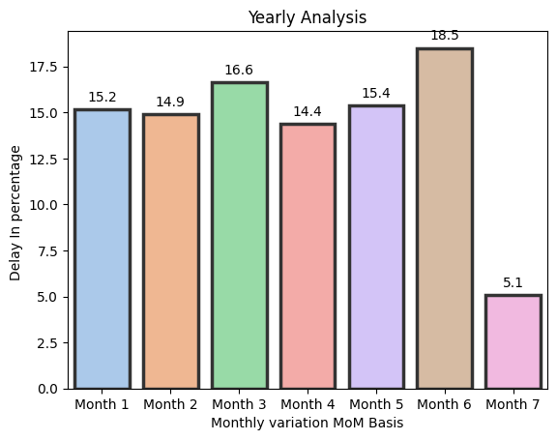

What about for flights leaving from Boston (BOS) specifically?

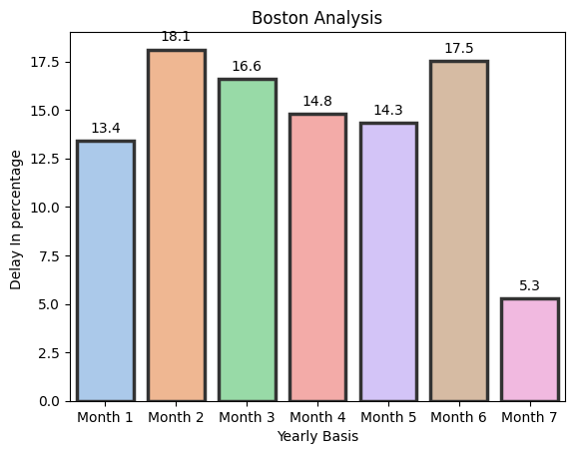

4) i.) How many flights were cancelled in 2015?

-> 64,285 flights were cancelled in 2015.  
ii.) What % of cancellations were due to weather?

-> 58.4 % of cancellations were due to weather

iii.) What % were due to the Airline/Carrier?

-> 25.4% were due to the Airline/Carrier.

5) Which airlines seem to be most and least reliable, in terms of on-time departure?

Ans. Here’s the pictorial representation in absolute numbers, South Western airlines seems to be the most reliable and Hawaiian Airlines seems to be the least if we just consider the absolute no, however

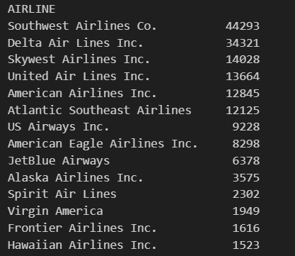

But when we compare it on a relative basis (ie with respect to the total no of flights of the airlines that took off) it draws a different picture.  
In that case Frontier AirLines emerges to be the top performer with only 3.7% of its total flights that actually took off and got delayed. The worst performer is Delta Air Lines 8.3%.

